**VISVESVARAYA TECHNOLOGICAL UNIVERSITY**

**“JnanaSangama”, Belgaum -590014, Karnataka.**



**LAB REPORT**

**on**

**BIG DATA ANALYTICS**

**(20CS6PEBDA)**

***Submitted by***

**KANALA BHUVANA REDDY (1BM19CS069)**

***in partial fulfillment for the award of the degree of***

**BACHELOR OF ENGINEERING**

***in***

**COMPUTER SCIENCE AND ENGINEERING**



**B.M.S. COLLEGE OF ENGINEERING**

**(Autonomous Institution under VTU)**

**BENGALURU-560019**

**May-2022 to July-2022**

**B. M. S. College of Engineering,**

**Bull Temple Road, Bangalore 560019**

(Affiliated To Visvesvaraya Technological University, Belgaum)

**Department of Computer Science and Engineering**



**CERTIFICATE**

This is to certify that the Lab work entitled “**BIG DATA ANALYTICS**” carried out by **KANALA BHUVANA REDDY (1BM19CS069),** who is bonafide student of **B. M. S. College of Engineering.** It is in partial fulfillment for the award of **Bachelor of Engineering in Computer Science and Engineering** of the Visvesvaraya Technological University, Belgaum during the year 2022. The Lab report has been approved as it satisfies the academic requirements in respect of a **Course Title - (Course code)** work prescribed for the said degree.

Name of the Lab-Incharge                **Dr.Asha G R**

Designation Assistant Professor

Department of CSE Department of CSE

BMSCE, Bengaluru BMSCE, Bengaluru

`

**Index Sheet**

|  |  |  |
| --- | --- | --- |
| **Sl. No.** | **Experiment Title** | **Page No.** |
| **1** | **Implement and demonstrate the FIND-S algorithm for finding the most specific**  **hypothesis based on a given set of training data samples.** | **5** |
| **2** | **For a given set of training data examples stored in a .CSV file, implement and**  **demonstrate the Candidate-Elimination algorithm to output a description of the set of**  **all hypotheses consistent with the training examples.** | **7** |
| **3** | **Write a program to demonstrate the working of the decision tree based ID3**  **algorithm. Use an appropriate data set for building the decision tree and apply this**  **knowledge to classify a new sample.** | **11** |
| **4** | **Implement the Linear Regression algorithm in order to fit data points. Select**  **appropriate data set for your experiment and draw graphs.** | **15** |
| **5** | **Write a program to implement the naïve Bayesian classifier for a sample training**  **data set stored as a .CSV file. Compute the accuracy of the classifier, considering**  **few test data sets** | **17** |

**Course Outcome**

|  |  |
| --- | --- |
| CO1 | Ability to apply the different learning algorithms. |
| CO2 | Ability to analyze the learning techniques for given dataset. |
| CO3 | Ability to design a model using machine learning to solve a problem. |
| CO4 | Ability to conduct practical experiments to solve problems using appropriate machine learning techniques. |

**LAB PROGRAM 1:**

Implement and demonstrate the FIND-S algorithm for finding the most specific

hypothesis based on a given set of training data samples.

Code:

i.

|  |
| --- |
| import csv |
|  |  |
|  | def updateHypothesis(x,h): |
|  | if h==[]: |
|  | return x |
|  |  |
|  | for i in range(0,len(h)): |
|  | if x[i].upper()!=h[i].upper(): |
|  | h[i] = '?' |
|  |  |
|  | return h |
|  |  |
|  | if __name__ == "__main__": |
|  | data = [] |
|  | h = [] |
|  |  |
|  | # reading csv file |
|  | with open('data.csv', 'r') as file: |
|  | reader = csv.reader(file) |
|  | print("Data: ") |
|  | for row in reader: |
|  | data.append(row) |
|  | print(row) |
|  |  |
|  | if data: |
|  | for x in data: |
|  | if x[-1].upper()=="YES": |
|  | x.pop() # removing last field |
|  | h = updateHypothesis(x,h) |
|  |  |
|  | print("\nHypothesis: ",h) |

ii. 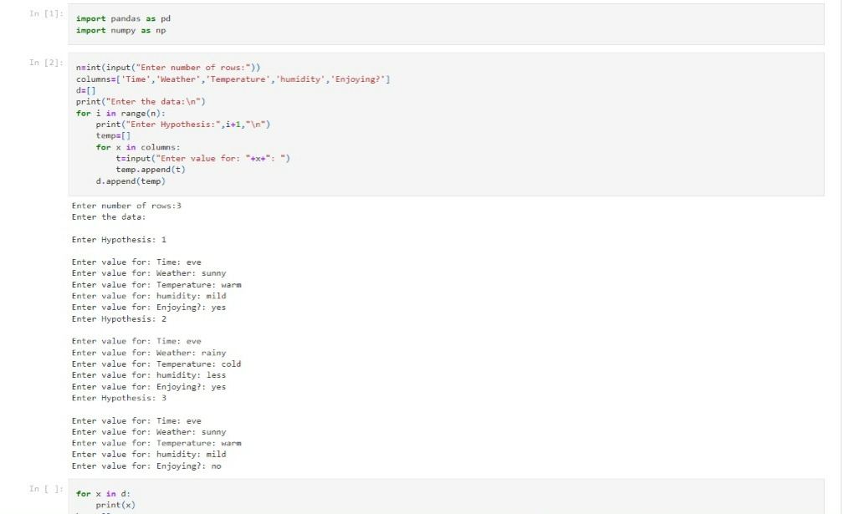

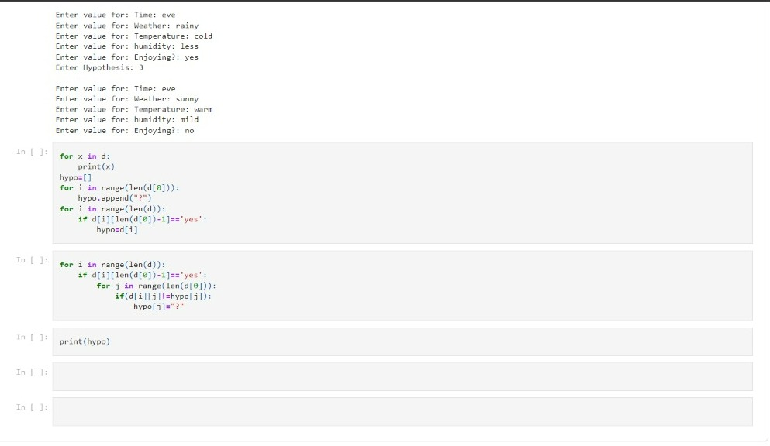

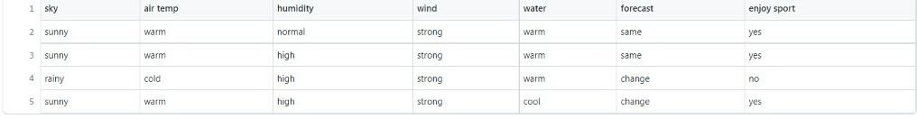

**LAB PROGRAM 2:**

For a given set of training data examples stored in a .CSV file, implement and demonstrate the Candidate-Elimination algorithm to output a description of the set of all hypotheses consistent with the training examples.

CODE:

**import** numpy **as** np

**import** pandas **as** pd

data **=** pd**.**read_csv("testdemo.csv")

concepts **=** np**.**array(data**.**iloc[:,0:**-**1])

print("\nInstances are:\n",concepts)

target **=** np**.**array(data**.**iloc[:,**-**1])

print("\nTarget Values are: ",target)

**def** learn(concepts, target):

specific_h **=** concepts[0]**.**copy()

print("\nSpecific Boundary: ", specific_h)

general_h **=** [["?" **for** i **in** range(len(specific_h))] **for** i **in** range(len(specific_h))]

print("\nGeneric Boundary: ",general_h)

**for** i, h **in** enumerate(concepts):

print("\nInstance", i**+**1 , "is ", h)

**if** target[i] **==** "yes":

**for** x **in** range(len(specific_h)):

**if** h[x]**!=** specific_h[x]:

specific_h[x] **=**'?'

general_h[x][x] **=**'?'

**if** target[i] **==** "no":

**for** x **in** range(len(specific_h)):

**if** h[x]**!=** specific_h[x]:

general_h[x][x] **=** specific_h[x]

**else**:

general_h[x][x] **=** '?'

print("Specific Boundary = ", specific_h)

print("Generic Boundary = ", general_h)

print("\n")

indices **=** [i **for** i, val **in** enumerate(general_h) **if** val **==** ['?', '?', '?', '?', '?', '?']]

**for** i **in** indices:

general_h**.**remove(['?', '?', '?', '?', '?', '?'])

**return** specific_h, general_h

s_final, g_final **=** learn(concepts, target)

print(" The Final Specific_h : ", s_final, sep**=**"\n")

print("The Final General_h : ", g_final, sep**=**"\n")

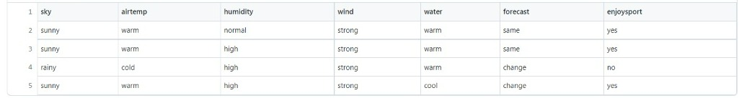

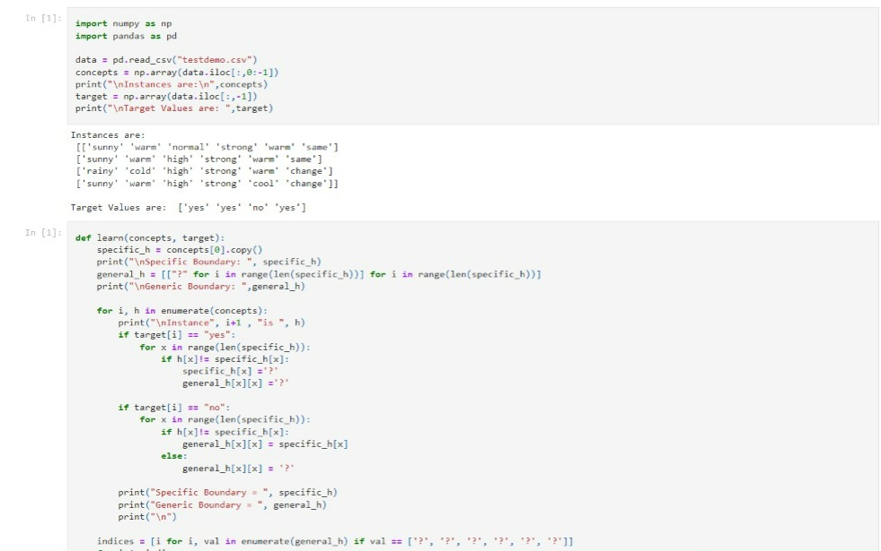

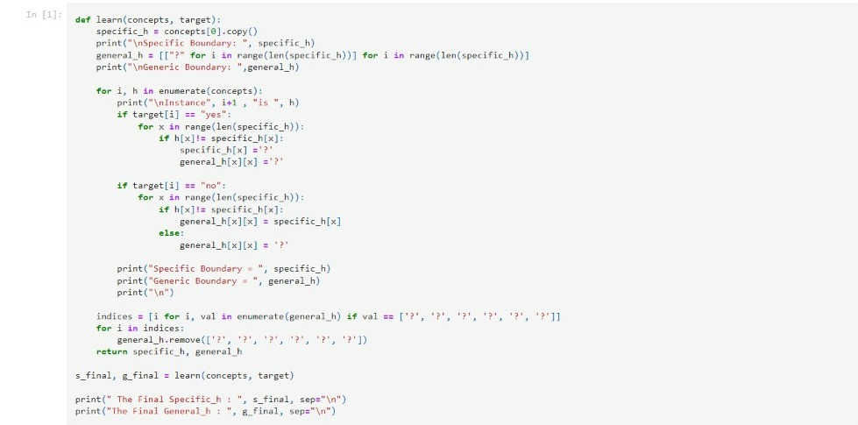

**LAB PROGRAM 3:**

Write a program to demonstrate the working of the decision tree based ID3 algorithm. Use an appropriate data set for building the decision tree and apply this knowledge to classify a new sample.

Code:

|  |
| --- |
| import math |
|  | import csv |
|  | def load_csv(filename): |
|  | lines=csv.reader(open(filename,"r")); |
|  | dataset = list(lines) |
|  | headers = dataset.pop(0) |
|  | return dataset,headers |
|  |  |
|  | class Node: |
|  | def __init__(self,attribute): |
|  | self.attribute=attribute |
|  | self.children=[] |
|  | self.answer="" |
|  |  |
|  | def subtables(data,col,delete): |
|  | dic={} |
|  | coldata=[row[col] for row in data] |
|  | attr=list(set(coldata)) |
|  |  |
|  | counts=[0]*len(attr) |
|  | r=len(data) |
|  | c=len(data[0]) |
|  | for x in range(len(attr)): |
|  | for y in range(r): |
|  | if data[y][col]==attr[x]: |
|  | counts[x]+=1 |
|  |  |
|  | for x in range(len(attr)): |
|  | dic[attr[x]]=[[0 for i in range(c)] for j in range(counts[x])] |
|  | pos=0 |
|  | for y in range(r): |
|  | if data[y][col]==attr[x]: |
|  | if delete: |
|  | del data[y][col] |
|  | dic[attr[x]][pos]=data[y] |
|  | pos+=1 |
|  | return attr,dic |
|  |  |
|  | def entropy(S): |
|  | attr=list(set(S)) |
|  | if len(attr)==1: |
|  | return 0 |
|  |  |
|  | counts=[0,0] |
|  | for i in range(2): |
|  | counts[i]=sum([1 for x in S if attr[i]==x])/(len(S)*1.0) |
|  |  |
|  | sums=0 |
|  | for cnt in counts: |
|  | sums+=-1*cnt*math.log(cnt,2) |
|  | return sums |
|  |  |
|  | def compute_gain(data,col): |
|  | attr,dic = subtables(data,col,delete=False) |
|  |  |
|  | total_size=len(data) |
|  | entropies=[0]*len(attr) |
|  | ratio=[0]*len(attr) |
|  |  |
|  | total_entropy=entropy([row[-1] for row in data]) |
|  | for x in range(len(attr)): |
|  | ratio[x]=len(dic[attr[x]])/(total_size*1.0) |
|  | entropies[x]=entropy([row[-1] for row in dic[attr[x]]]) |
|  | total_entropy-=ratio[x]*entropies[x] |
|  | return total_entropy |
|  |  |
|  | def build_tree(data,features): |
|  | lastcol=[row[-1] for row in data] |
|  | if(len(set(lastcol)))==1: |
|  | node=Node("") |
|  | node.answer=lastcol[0] |
|  | return node |
|  |  |
|  | n=len(data[0])-1 |
|  | gains=[0]*n |
|  | for col in range(n): |
|  | gains[col]=compute_gain(data,col) |
|  | split=gains.index(max(gains)) |
|  | node=Node(features[split]) |
|  | fea = features[:split]+features[split+1:] |
|  |  |
|  |  |
|  | attr,dic=subtables(data,split,delete=True) |
|  |  |
|  | for x in range(len(attr)): |
|  | child=build_tree(dic[attr[x]],fea) |
|  | node.children.append((attr[x],child)) |
|  | return node |
|  |  |
|  | def print_tree(node,level): |
|  | if node.answer!="": |
|  | print(" "*level,node.answer) |
|  | return |
|  |  |
|  | print(" "*level,node.attribute) |
|  | for value,n in node.children: |
|  | print(" "*(level+1),value) |
|  | print_tree(n,level+2) |
|  |  |
|  |  |
|  | def classify(node,x_test,features): |
|  | if node.answer!="": |
|  | print(node.answer) |
|  | return |
|  | pos=features.index(node.attribute) |
|  | for value, n in node.children: |
|  | if x_test[pos]==value: |
|  | classify(n,x_test,features) |
|  |  |
|  | '''Main program''' |
|  | dataset,features=load_csv("id3.csv") |
|  | node1=build_tree(dataset,features) |
|  |  |
|  | print("The decision tree for the dataset using ID3 algorithm is") |
|  | print_tree(node1,0) |
|  | testdata,features=load_csv("id3_test_1.csv") |
|  |  |
|  | for xtest in testdata: |
|  | print("The test instance:",xtest) |
|  | print("The label for test instance:") |
|  | classify(node1,xtest,features) |

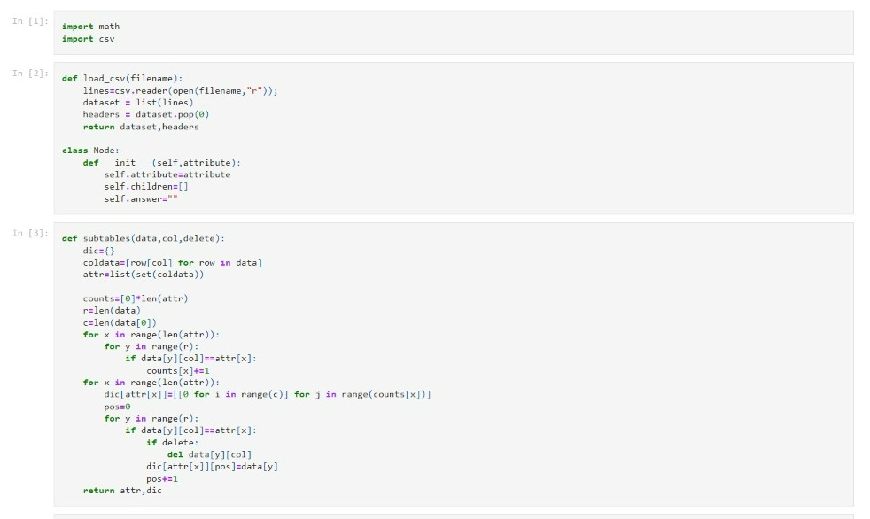

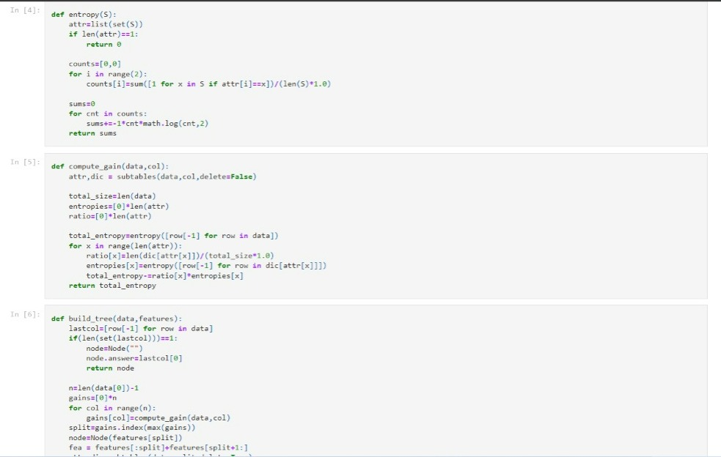

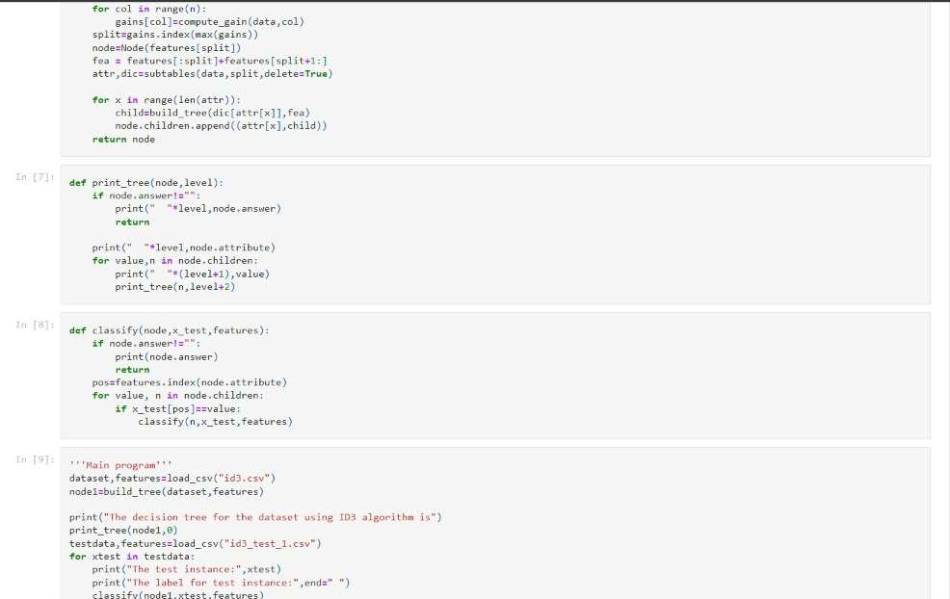

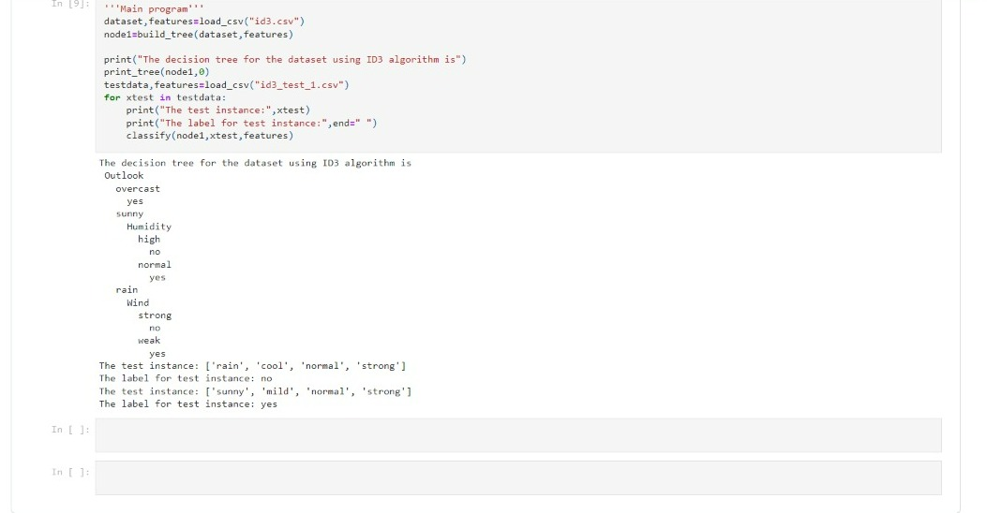

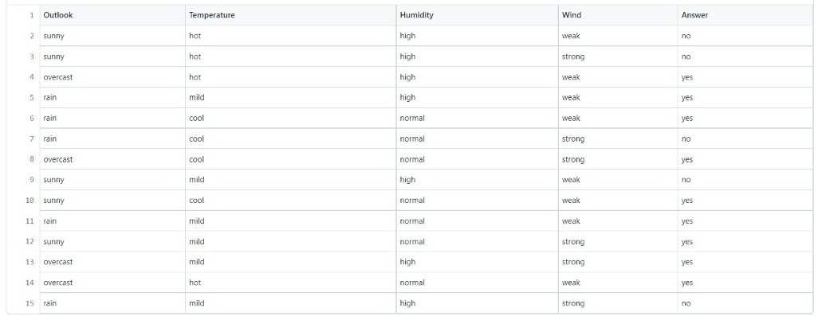

**LAB PROGRAM 4:**

Implement the Linear Regression algorithm in order to fit data points. Select

appropriate data set for your experiment and draw graphs.

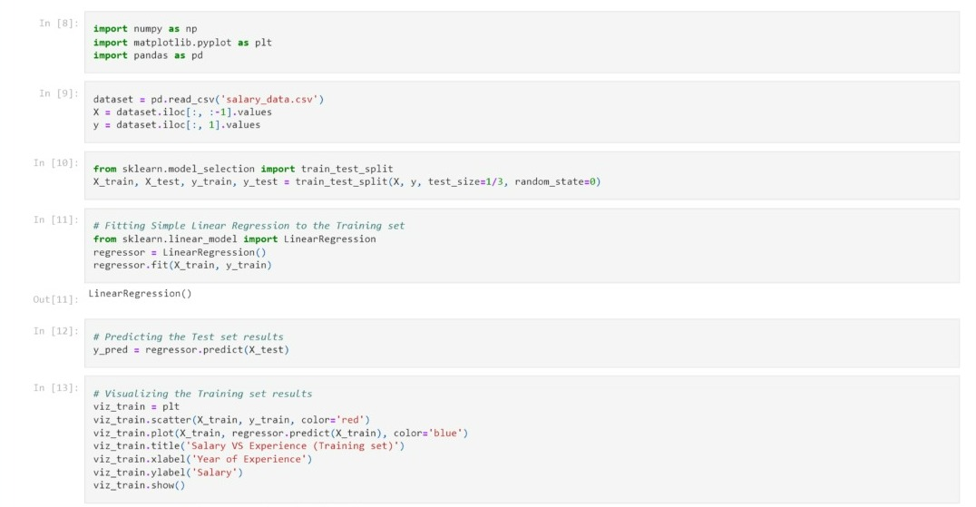

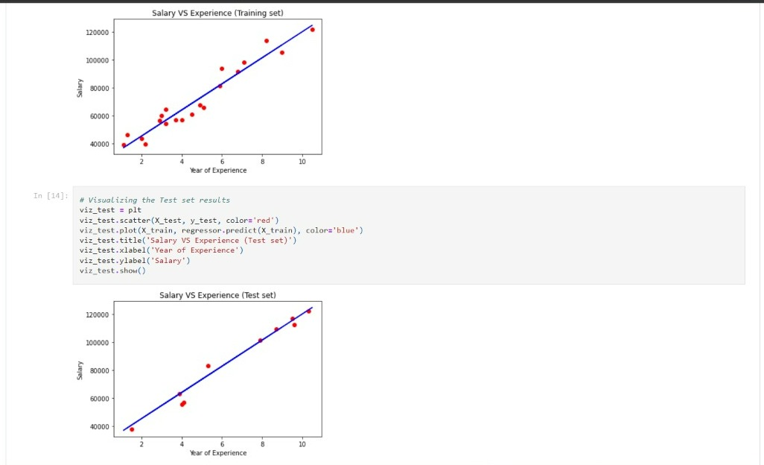

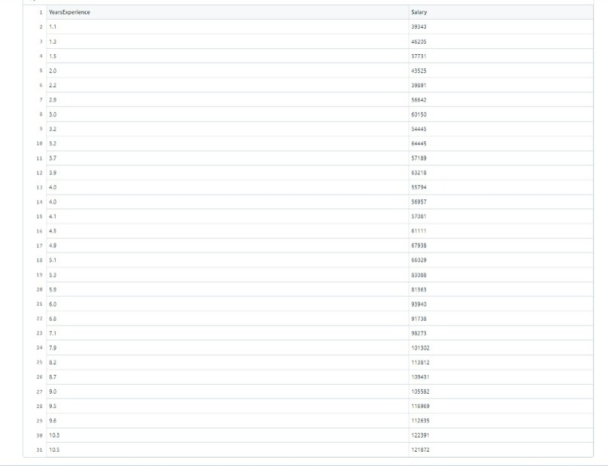

**PROGRAM 5:**

Write a program to implement the naïve Bayesian classifier for a sample training

data set stored as a .CSV file. Compute the accuracy of the classifier, considering

few test data sets

Code:

import pandas as pd

from sklearn.model_selection import train_test_split

from sklearn.naive_bayes import GaussianNB

from sklearn import metrics

df = pd.read_csv("pima_indian.csv")

feature_col_names = ['num_preg', 'glucose_conc', 'diastolic_bp', 'thickness', 'insulin', 'bmi', 'diab_pred', 'age']

predicted_class_names = ['diabetes']

X = df[feature_col_names].values # these are factors for the prediction

y = df[predicted_class_names].values # this is what we want to predict

#splitting the dataset into train and test data

xtrain,xtest,ytrain,ytest=train_test_split(X,y,test_size=0.33)

print ('\n the total number of Training Data :',ytrain.shape)

print ('\n the total number of Test Data :',ytest.shape)

# Training Naive Bayes (NB) classifier on training data.clf = GaussianNB().fit(xtrain,ytrain.ravel())

predicted = clf.predict(xtest)

predictTestData= clf.predict([[6,148,72,35,0,33.6,0.627,50]])

#printing Confusion matrix, accuracy, Precision and Recall

print('\n Confusion matrix')

print(metrics.confusion_matrix(ytest,predicted))

print('\n Accuracy of the classifier is',metrics.accuracy_score(ytest,predicted))

print('\n The value of Precision', metrics.precision_score(ytest,predicted))

print('\n The value of Recall', metrics.recall_score(ytest,predicted))

print("Predicted Value for individual Test Data:", predictTestData)

